Artificial Intelligence  AI-2002 | Lab 08  Adversarial Search
National University of Computer & Emerging Sciences – NUCES – Karachi

Course Code: AI-2002 | Artificial Intelligence Lab

Contents
1. Objectives 3
2. Introduction to Game Theory 3
2.1 Elements of Game Playing Search 3
2.2 Types of Algorithms in Adversarial Search 5
2.2.1 MiniMax Algorithm 5
2.2.1.1 Pseudo Code for MiniMax Algorithm 8
2.2.1.2 MiniMax Algorithm - Example 9
2.2.2 Alpha-Beta Pruning 12
2.2.2.1 Pseudo Code for Alpha-Beta Pruning Algorithm 13
2.2.2.2 Working of Alpha-Beta Pruning Algorithm 14
2.2.2.3 MiniMax with Alpha-Beta Pruning Algorithm - Example 19

1. Objectives
- An Introduction to Game theory and Adversarial Search Algorithm.
- Tasks

2. Introduction to Game Theory
Game Theory is a branch of mathematics used to model the strategic interaction between different players in a context with predefined rules and outcomes. According to game theory, a game is played between two players. To complete the game, one has to win the game, and the other loses automatically.
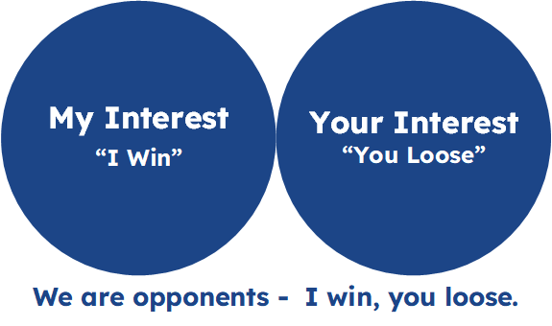
Figure 01: Adversarial Search

Adversarial Search is a Game-Playing Technique where the agents are surrounded by a competitive environment. A conflicting goal is given to the agents (multiagent). These agents compete with one another and try to defeat one another in order to win the game. Such conflicting goals give rise to the adversarial search. Here, game-playing means discussing those games where human intelligence and logic factor is used, excluding other factors such as luck factor. Tic-tac-toe, Chess, Checkers, etc., are such types of games where no luck factor works, only the mind work

2.1 Elements of Game Playing Search
To play a game, we use a Game Tree to know all the possible choices and to pick the best one out. So, It is the initial state from which a game begins.
There are the following elements of game-playing:

Player(s): It defines which player is having the current turn to make a move in the state.
Actions(s): It defines the set of legal moves to be used in a state.
Result(s, a): It is a transition model which defines the result of a move.
Terminal-Test(s): It defines that the game has ended and returns true.
Utility(s, p): It defines the final value with which the game has ended. This function is also known as the Objective function or Payoff function. The price which the winner will get i.e.
- -1: If the Player loses.
- +1: If the Player wins.
- 0: If there is a draw between the Players.

For example, in chess, tic-tac-toe, we have two or three possible outcomes. Either to win, to lose, or to draw the match with values +1,-1, or 0.
Let’s understand the working of the elements with the help of a game tree designed for tic-tac-toe.
Here, the node represents the game state and the edges represent the moves taken by the players.
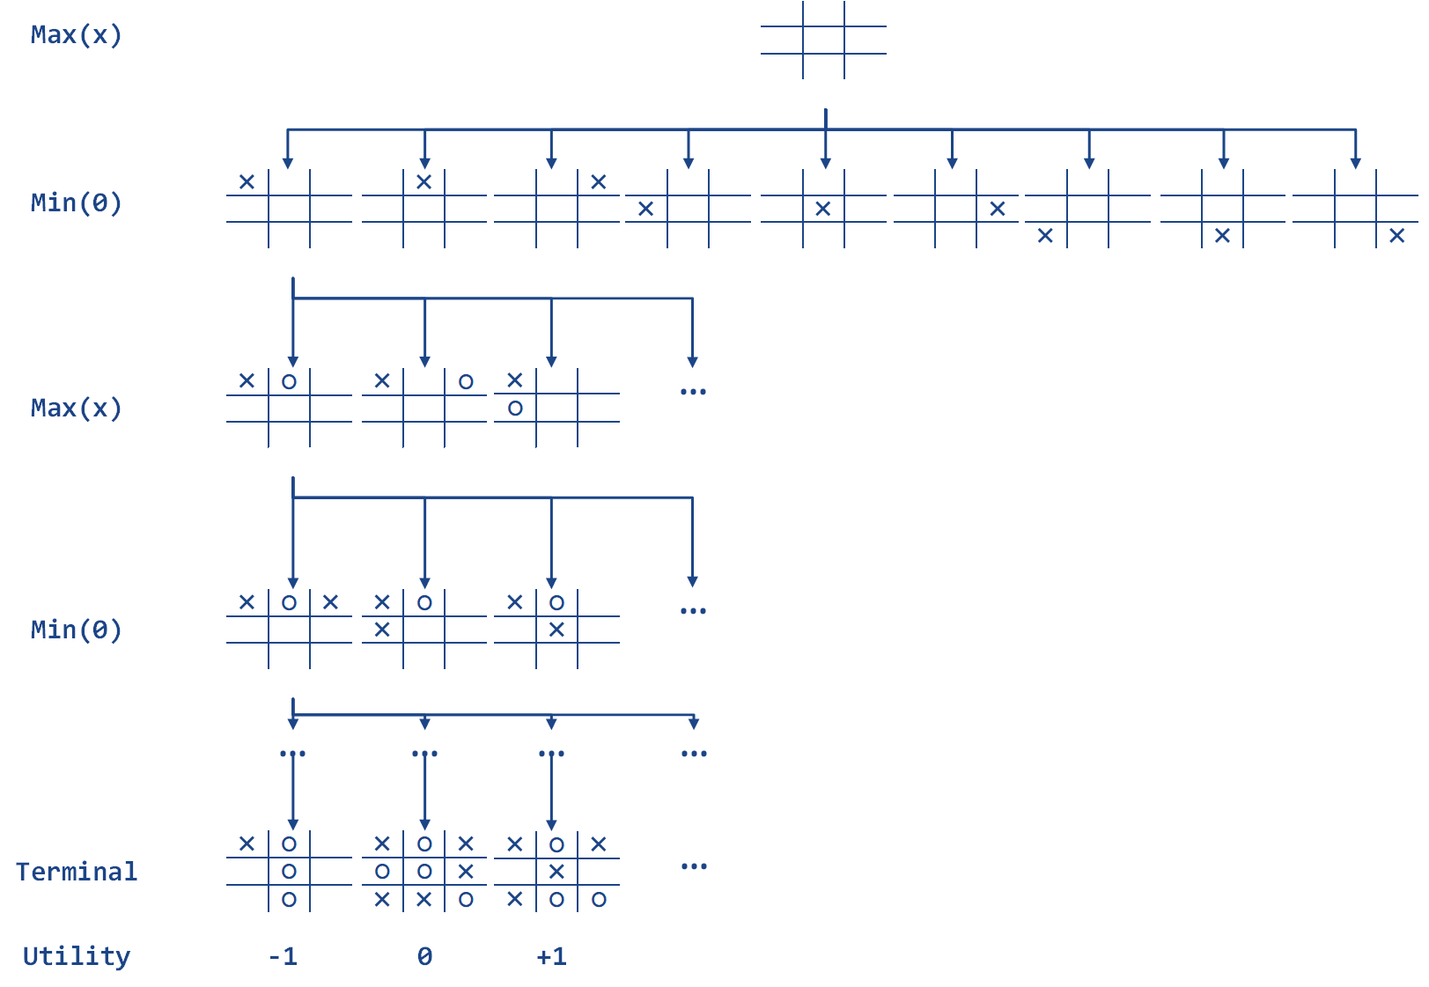
Figure 02: A Game Tree for Tic-Tac-Toe

Initial State (S_{o}): The top node in the game tree represents the initial state in the tree and shows all the possible choices to pick out one.
Player(s): There are two players, Max and Min. Max begins the game by picking one best move and placing X in the empty square box.
Actions(s): Both the players can make moves in the empty boxes chance by chance.
Results(s, a): The moves made by Min and Max will decide the outcome of the game.
Terminal-Test(s): When all the empty boxes will be filled, it will be the terminating state of the game.
Utility: At the end, we will get to know who wins: Max or Min, and accordingly, the price will be given to them.

2.2 Types of Algorithms in Adversarial Search
Unlike Normal Search, in Adversarial search, the result depends on the players which will decide the result of the game. It is also obvious that the solution for the goal state will be an optimal solution because the player will try to win the game with the shortest path and under limited time.

2.2.1 MiniMax Algorithm
Minimax is a decision-making strategy, which is used to minimize the losing chances in a game and to maximize the winning chances. This strategy is also known as ‘Minmax’. It is a two-player game strategy where if one wins, the other loses the game. We can easily understand this strategy via a game tree where the nodes represent the states of the game and the edges represent the moves made by the players in the game. Players will be two namely:

Min: Decrease the chances of winning the game.
Max: Increases his chances of winning the game.

In the minimax strategy, the result of the game or the utility value is generated by a heuristic function, which propagates from the leaf nodes back to the root node using backtracking. At each node, the algorithm selects the maximum or minimum value depending on whether it is the Max or Min player's turn.

The Minimax strategy follows the Depth-First Search (DFS) concept. In this approach, there are two players, Min and Max, who take turns alternately during the game. For instance, when Max makes a move, the next turn belongs to Min. Once Max makes a move, it is fixed and cannot be changed.
The Minimax strategy follows the Depth-First Search (DFS) concept to traverse the game tree. In this approach, two players, Min and Max, alternate turns during the game. For example, when Max makes a move, the next turn belongs to Min. During the evaluation of a specific path, the move made by Max is treated as fixed within that path. However, the algorithm backtracks to explore other paths and determine the optimal move. The DFS approach ensures each path is explored fully before backtracking, making it more suitable than Breadth-First Search (BFS) for this algorithm.
Flow of Minimax Algorithm:
- Keep on generating the game tree/ search tree till a limit.
- Compute the move using a heuristic function.
- Propagate the values from the leaf node to the current position following the minimax strategy.

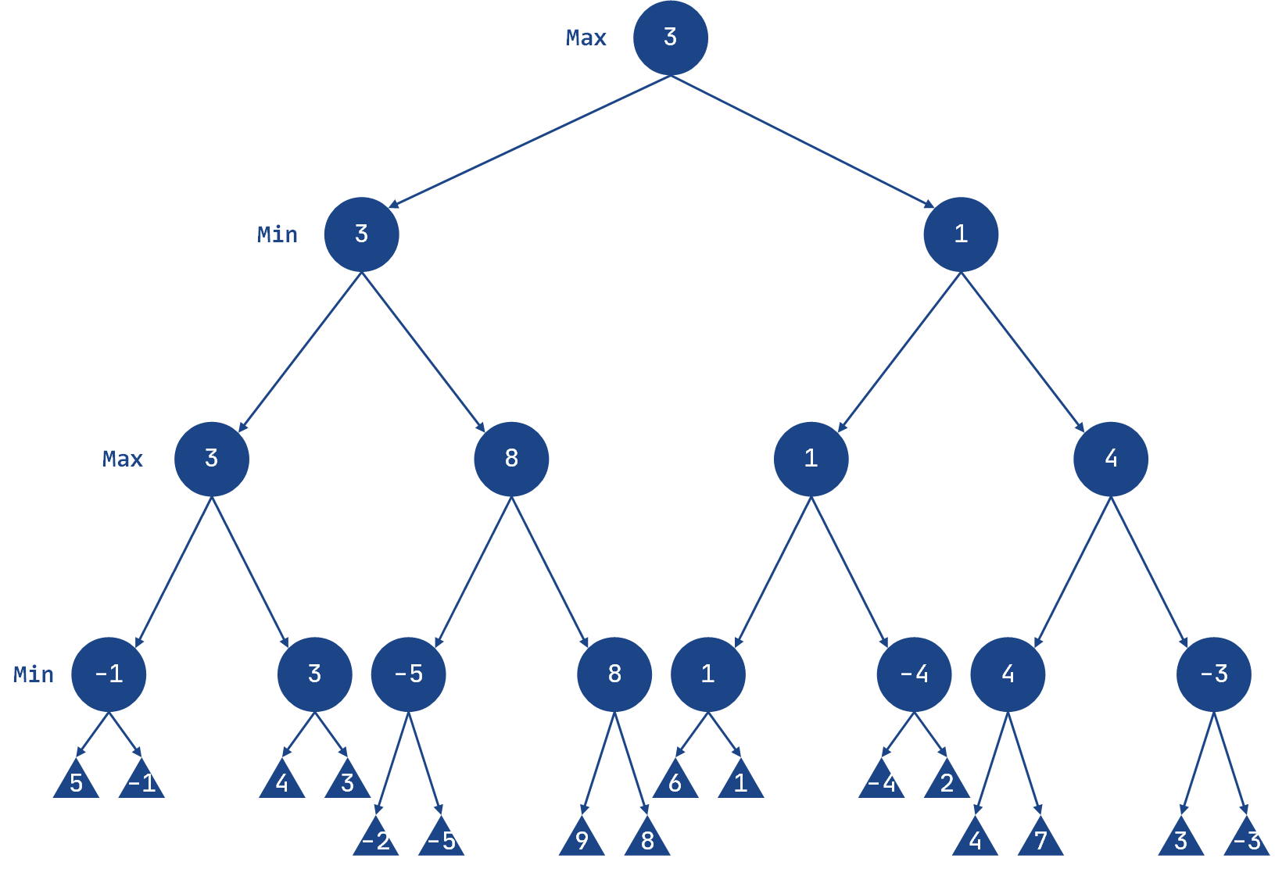

Players in the Game:
- Two players: Max and Min.
- They alternate turns throughout the game.
Max's Turn:
- Max starts the game by selecting a path and exploring (propagating) all the nodes along that path.
- After exploring the nodes, Max backtracks to the initial node.
- Max then selects the best path, i.e., the one where his utility value is maximized.
Min's Turn:
- After Max completes, it’s Min's turn.
- Min explores paths and backtracks afterward, selecting the path that minimizes Max's chances of winning by choosing the minimum utility value among its successors.
- However, Min chooses the path that minimizes Max's chances of winning or reduces the utility value.
Node Value Selection:
- If the current level is a minimizing level (Min's turn), the node accepts the minimum value from its successor nodes.
- If the current level is a maximizing level (Max's turn), the node accepts the maximum value from its successor nodes.
Key Concept:
- Max tries to maximize the utility value.
- Min tries to minimize Max's chances by reducing the utility value.

2.2.1.1 Pseudo Code for MiniMax Algorithm

function minimax(node, depth, maximizingPlayer) is
if depth == 0 or node is a terminal node then
return static evaluation of node

if MaximizingPlayer then // for Maximizer Player
maxEva = -infinity
for each child of node do
eva = minimax(child, depth - 1, false)
maxEva = max(maxEva, eva) // Gives the maximum of the values
return maxEva
else // for Minimizer Player
minEva = +infinity
for each child of node do
eva = minimax(child, depth - 1, true)
minEva = min(minEva, eva) // Gives the minimum of the values
return minEva

2.2.1.2 MiniMax Algorithm - Example
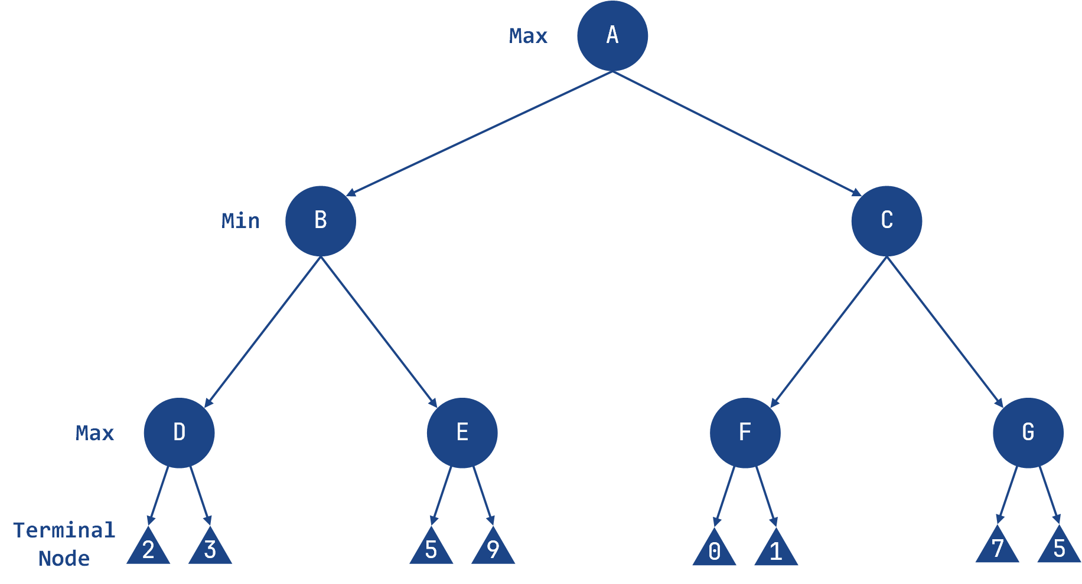

import math

class Node:
def __init__(self, value=None):
self.value = value
self.children = []
self.minmax_value = None

class MinimaxAgent:
def __init__(self, depth):
self.depth = depth

def formulate_goal(self, node):
# in Minimax, the goal is to compute the minimax value for the root node
return "Goal reached" if node.minmax_value is not None else "Searching"

def act(self, node, environment):
goal_status = self.formulate_goal(node)
if goal_status == "Goal reached":
return f"Minimax value for root node: {node.minmax_value}"
else:
return environment.compute_minimax(node, self.depth)

class Environment:
def __init__(self, tree):
self.tree = tree
self.computed_nodes = []

def get_percept(self, node):
return node

def compute_minimax(self, node, depth, maximizing_player=True):
if depth == 0 or not node.children:
self.computed_nodes.append(node.value)
return node.value

if maximizing_player:
value = -math.inf
for child in node.children:
child_value = self.compute_minimax(child, depth - 1, False)
value = max(value, child_value)
node.minmax_value = value
self.computed_nodes.append(node.value)
return value
else:
value = math.inf
for child in node.children:
child_value = self.compute_minimax(child, depth - 1, True)
value = min(value, child_value)
node.minmax_value = value
self.computed_nodes.append(node.value)
return value

def run_agent(agent, environment, start_node):
percept = environment.get_percept(start_node)
agent.act(percept, environment)

# sample tree
root = Node('A')
n1 = Node('B')
n2 = Node('C')
root.children = [n1, n2]

n3 = Node('D')
n4 = Node('E')
n5 = Node('F')
n6 = Node('G')
n1.children = [n3, n4]
n2.children = [n5, n6]

n7 = Node(2)
n8 = Node(3)
n9 = Node(5)
n10 = Node(9)
n3.children = [n7, n8]
n4.children = [n9, n10]

n11 = Node(0)
n12 = Node(1)
n13 = Node(7)
n14 = Node(5)
n5.children = [n11, n12]
n6.children = [n13, n14]

# define depth for Minimax
depth = 3

agent = MinimaxAgent(depth)
environment = Environment(root)

run_agent(agent, environment, root)

print("Computed Nodes:", environment.computed_nodes)

print("Minimax values:")
print("A:", root.minmax_value)
print("B:", n1.minmax_value)
print("C:", n2.minmax_value)
print("D:", n3.minmax_value)
print("E:", n4.minmax_value)
print("F:", n5.minmax_value)
print("G:", n6.minmax_value)
Output | Computed Nodes: [2, 3, 'D', 5, 9, 'E', 'B', 0, 1, 'F', 7, 5, 'G', 'C', 'A']  Minimax values:  A: 3  B: 3  C: 1  D: 3  E: 9  F: 1  G: 7

2.2.2 Alpha-Beta Pruning
Alpha-Beta Pruning is an optimized version of the Minimax algorithm. One major drawback of the Minimax strategy is that it explores every node in the game tree, which can be time-consuming and computationally expensive. Alpha-Beta Pruning addresses this issue by reducing the number of nodes explored in the search tree.
The key idea behind alpha-beta pruning is to "prune" or eliminate branches of the tree that do not affect the final decision. This allows the algorithm to focus only on relevant paths while still making the same decisions as the Minimax algorithm. By using this technique, unnecessary calculations are avoided, improving efficiency.
Alpha-Beta Pruning works based on two threshold values:
- Alpha (-∞): The best value that the Max player can guarantee at any point. It acts as the lower bound (negative infinity initially).

- Beta (+∞): The best value that the Min player can guarantee at any point. It acts as the upper bound (positive infinity initially).
This pruning mechanism ensures that branches that cannot influence the outcome are skipped, making the algorithm faster without compromising accuracy.

2.2.2.1 Pseudo Code for Alpha-Beta Pruning Algorithm

function minimax(node, depth, alpha, beta, maximizingPlayer) is
if depth == 0 or node is a terminal node then
return static evaluation of node

if MaximizingPlayer then // for Maximizer Player
maxEva = -infinity
for each child of node do
eva = minimax(child, depth - 1, alpha, beta, false)
maxEva = max(maxEva, eva)
alpha = max(alpha, maxEva)
if beta <= alpha then
break
return maxEva
else // for Minimizer Player
minEva = +infinity
for each child of node do
eva = minimax(child, depth - 1, alpha, beta, true)
minEva = min(minEva, eva)
beta = min(beta, eva)
if beta <= alpha then
break
return minEva

2.2.2.2 Working of Alpha-Beta Pruning Algorithm
Let's take an example of a two-player search tree to understand the working of Alpha-beta pruning.

Step 1: Initialize the Algorithm
- The Max player starts at Node A.
- Initialize alpha (α) and beta (β) values:
  - α = -∞ (worst case for Max)
  - β = +∞ (worst case for Min)
- Pass these values to the next node (Node B).
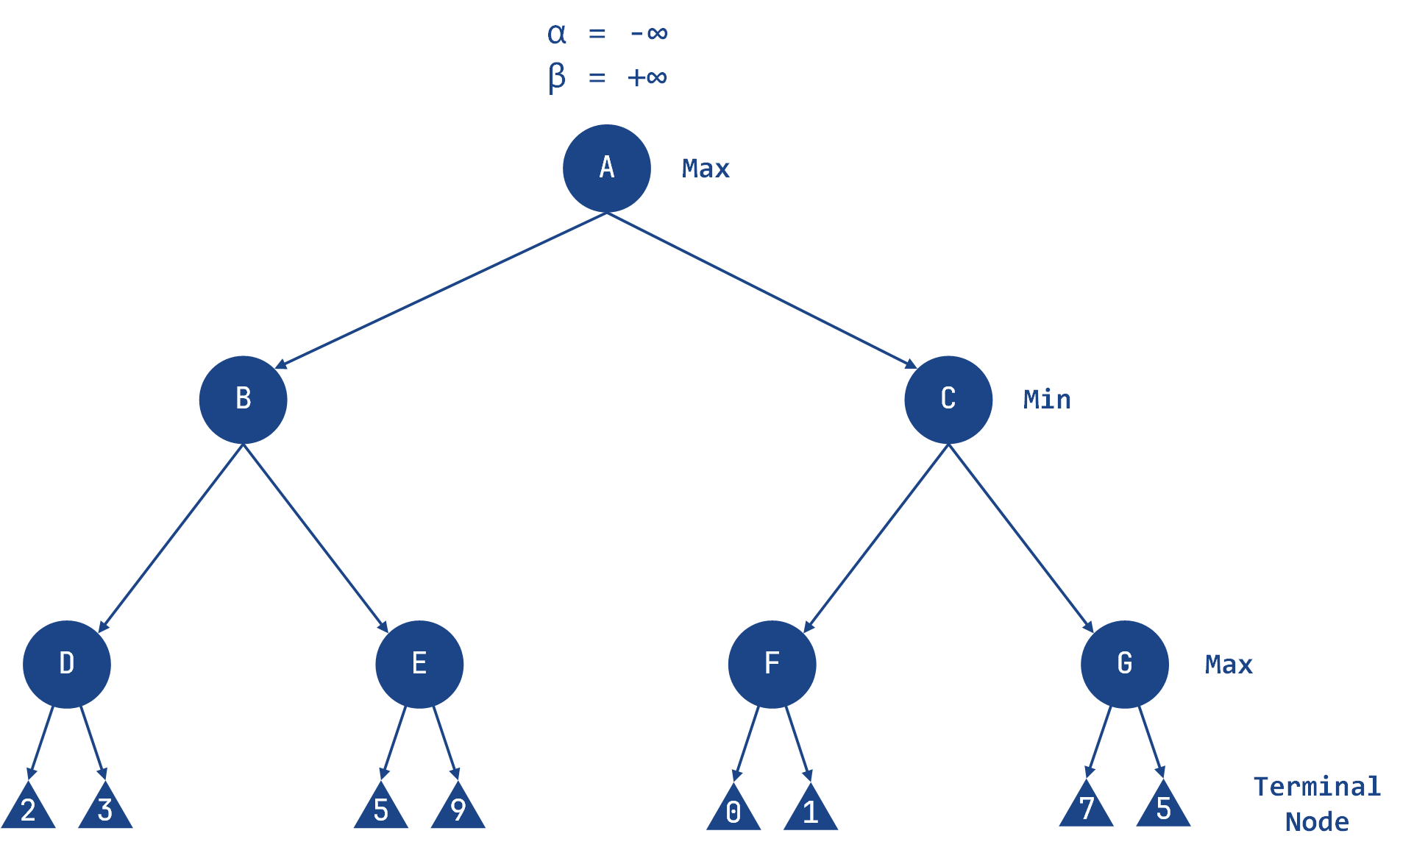
Step 2: Evaluate Node D (Max's Turn)
- At Node D, it's Max's turn.
- Compare the node's children values:
  - Left child value = 2
  - Right child value = 3
- Update α:
  - α = max(2, 3) = 3

- Set the value of Node D to 3.
Step 3: Backtrack to Node B (Min's Turn)
- Return to Node B, where it's Min's turn.
- Update β:
  - β = min(∞, 3) = 3
- Now, at Node B:
  - α = -∞
  - β = 3
- Pass these values to the next child of Node B, which is Node E.
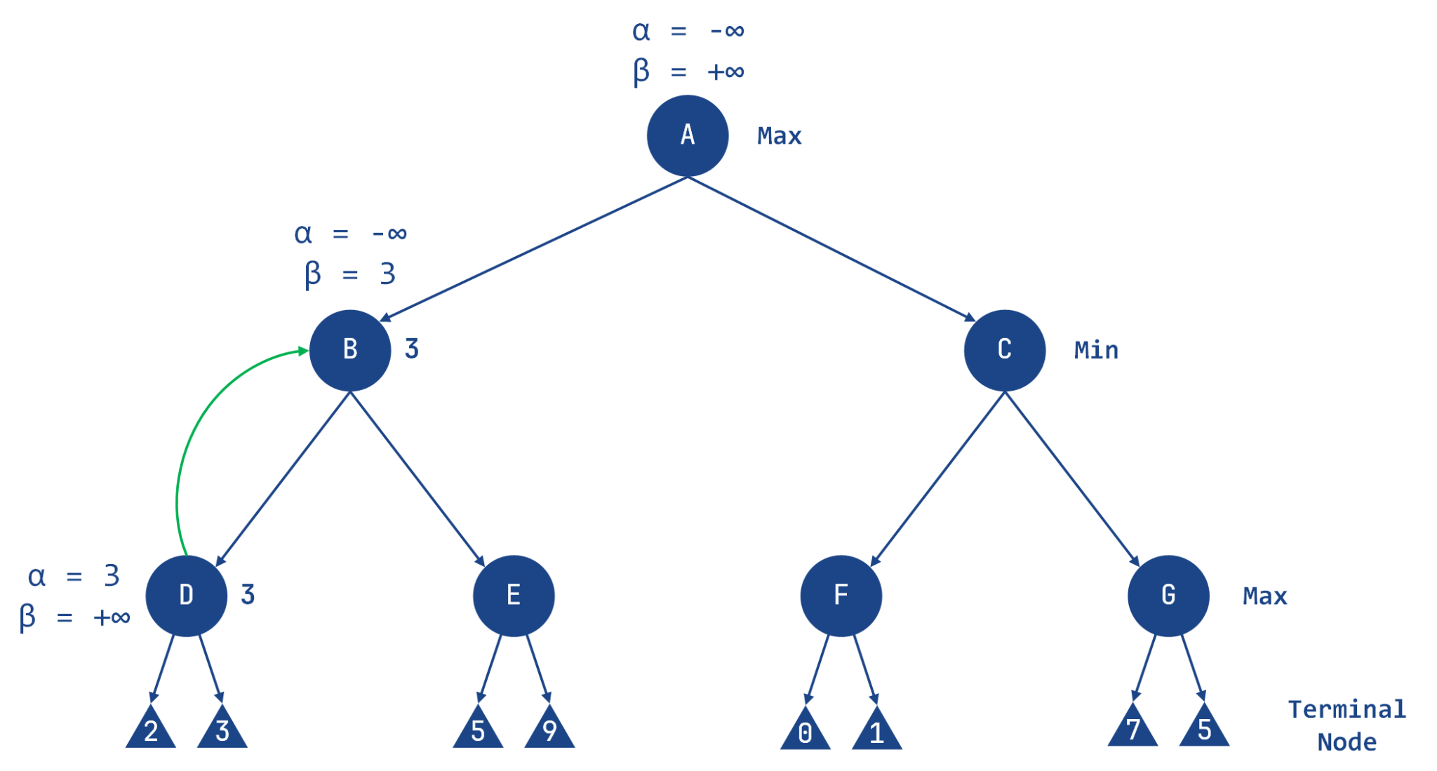
Step 4: Evaluate Node E (Max's Turn)
- At Node E, it's Max's turn.
- Compare the node's left child value:
  - Left child value = 5
- Update α:
  - α = max(-∞, 5) = 5
- Now, at Node E:
  - α = 5
  - β = 3
- Check the pruning condition:
  - Since α >= β, prune the right child of Node E.

- Set the value of Node E to 5.

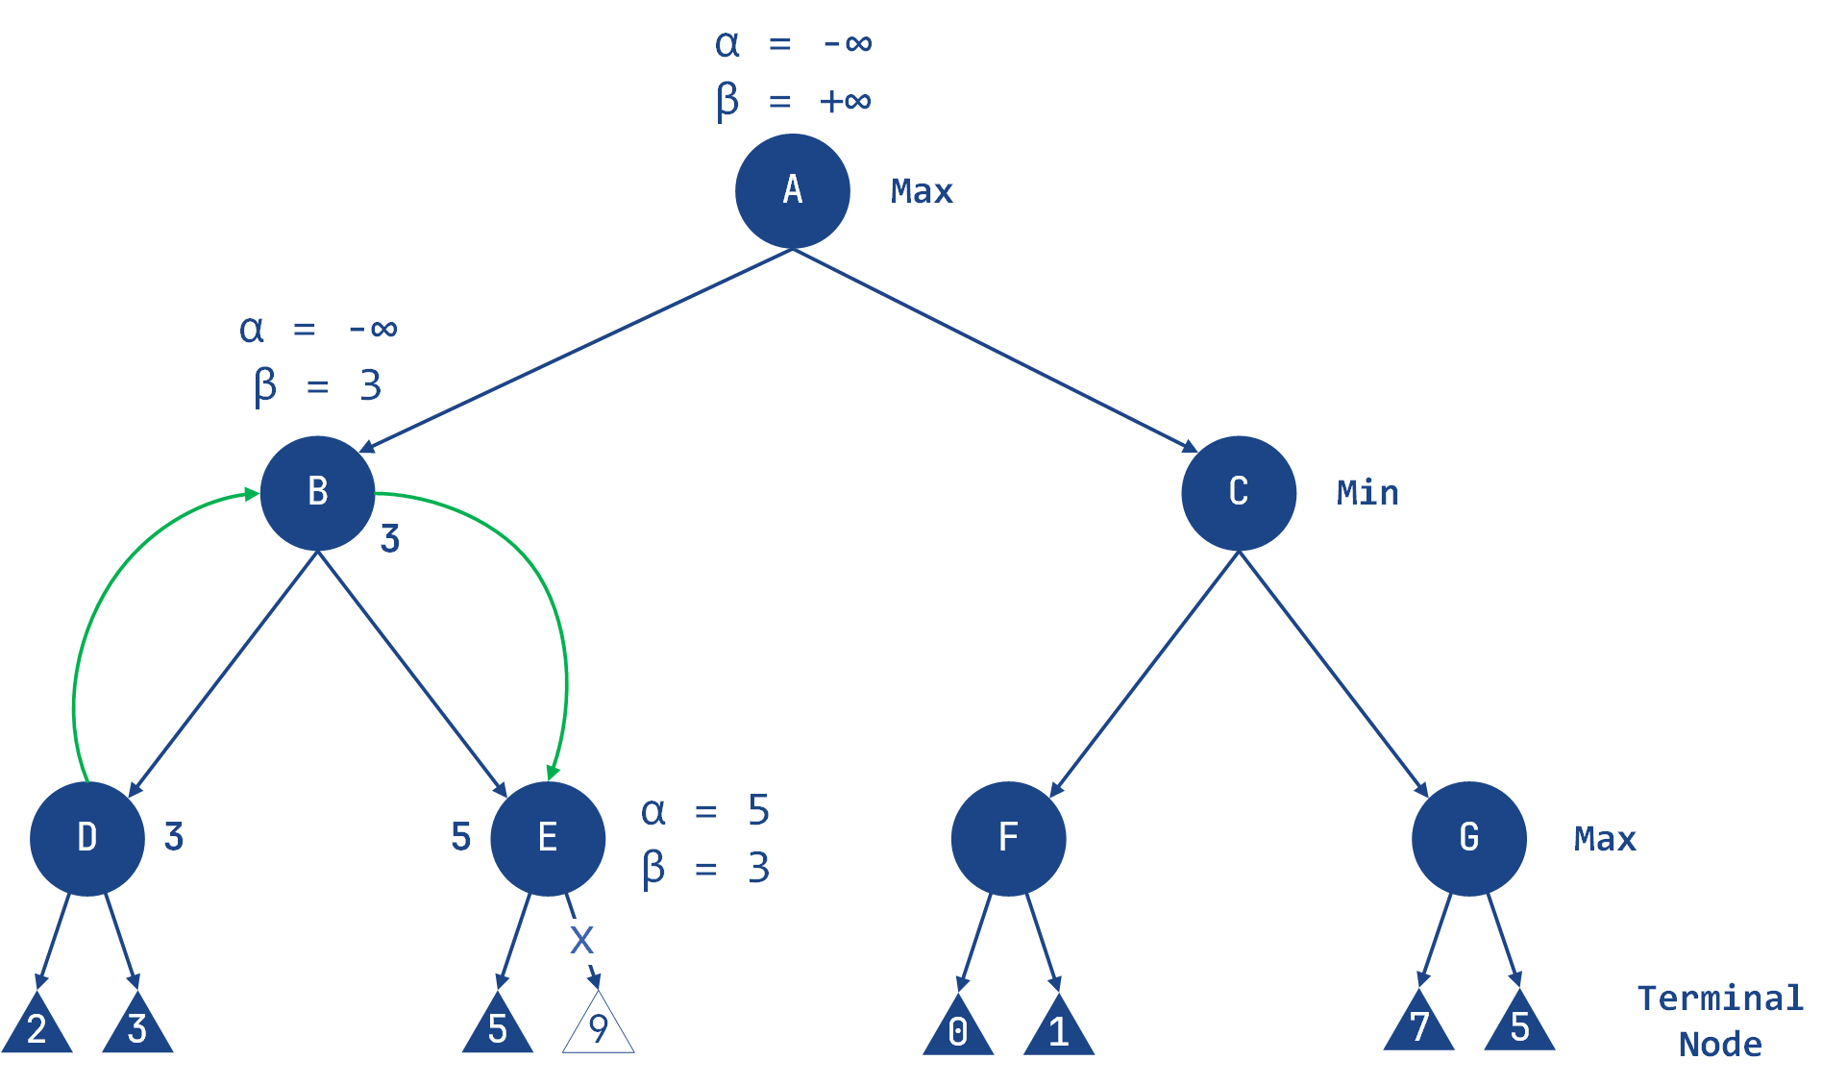
Step 5: Backtrack to Node A (Max's Turn)
- Return to Node A, where it's Max's turn.
- Update α:
  - α = max(-∞, 3) = 3
- Now, at Node A:
  - α = 3
  - β = +∞
- Pass these values to the next child of Node A, which is Node C.

Step 6: Evaluate Node F (Max's Turn)
- At Node F, it's Max's turn.
- Compare the node's children values:
  - Left child value = 0
  - Right child value = 1
- Update α:
  - α = max(3, 0) = 3
  - α = max(3, 1) = 3 (remains unchanged)

- Set the value of Node F to 1.

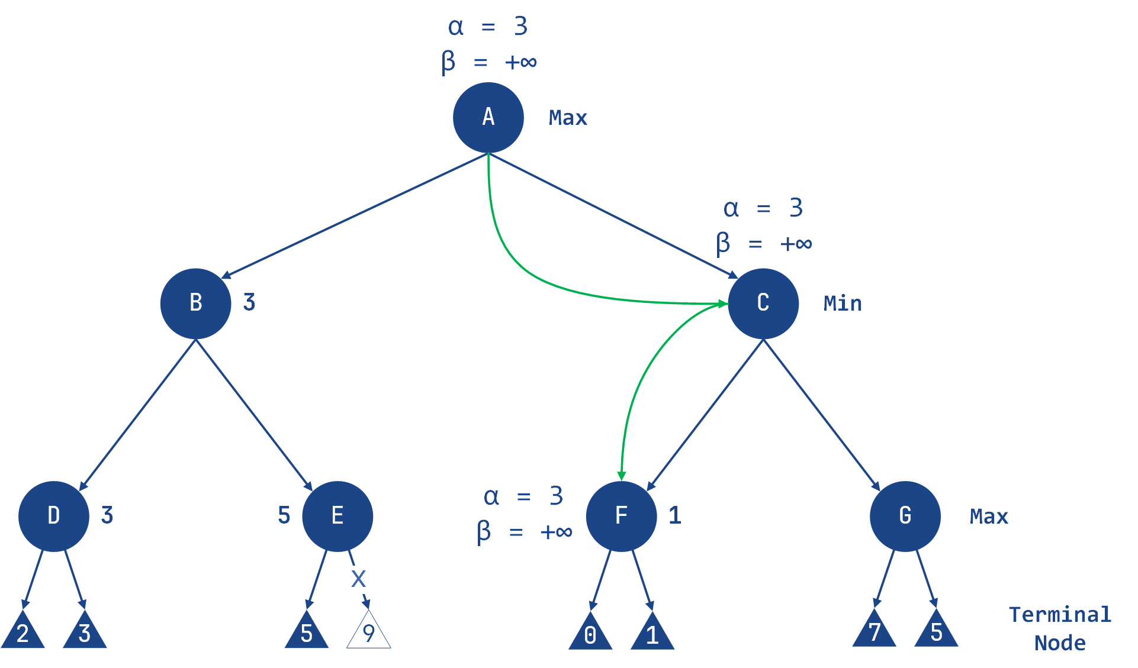
Step 7: Backtrack to Node C (Min's Turn)
- Return to Node C, where it's Min's turn.
- Update β:
  - β = min(∞, 1) = 1
- Now, at Node C:
  - α = 3
  - β = 1
- Check the pruning condition:
  - Since α >= β, prune the right child of Node C (Node G).
- Set the value of Node C to 1.

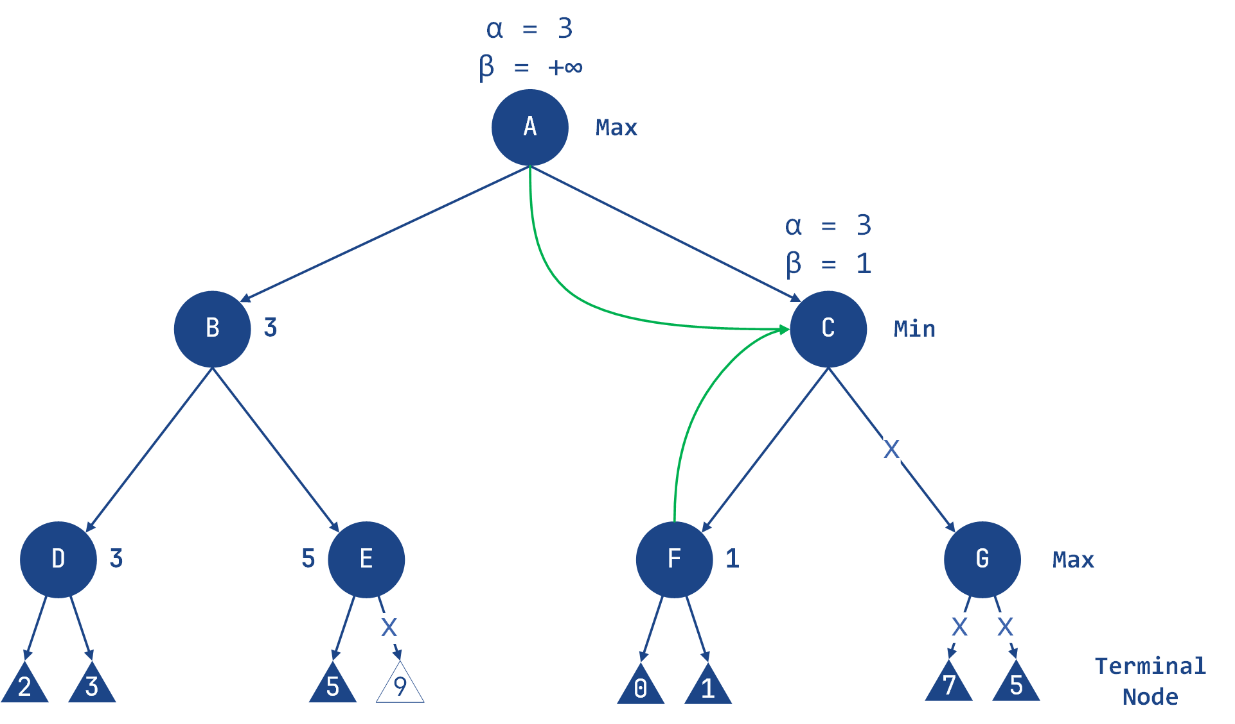

Step 8: Finalize Node A (Max's Turn)
- Return to Node A, where it's Max's turn.
- Update α:
  - α = max(3, 1) = 3
- The optimal value for the Max player is 3.

Final Tree
- Nodes computed: A, B, D, E, C, F
- Nodes pruned: Right child of E, Right child of C (Node G)
- The final tree shows the computed nodes and the pruned nodes. The optimal value for the Max player is 3.

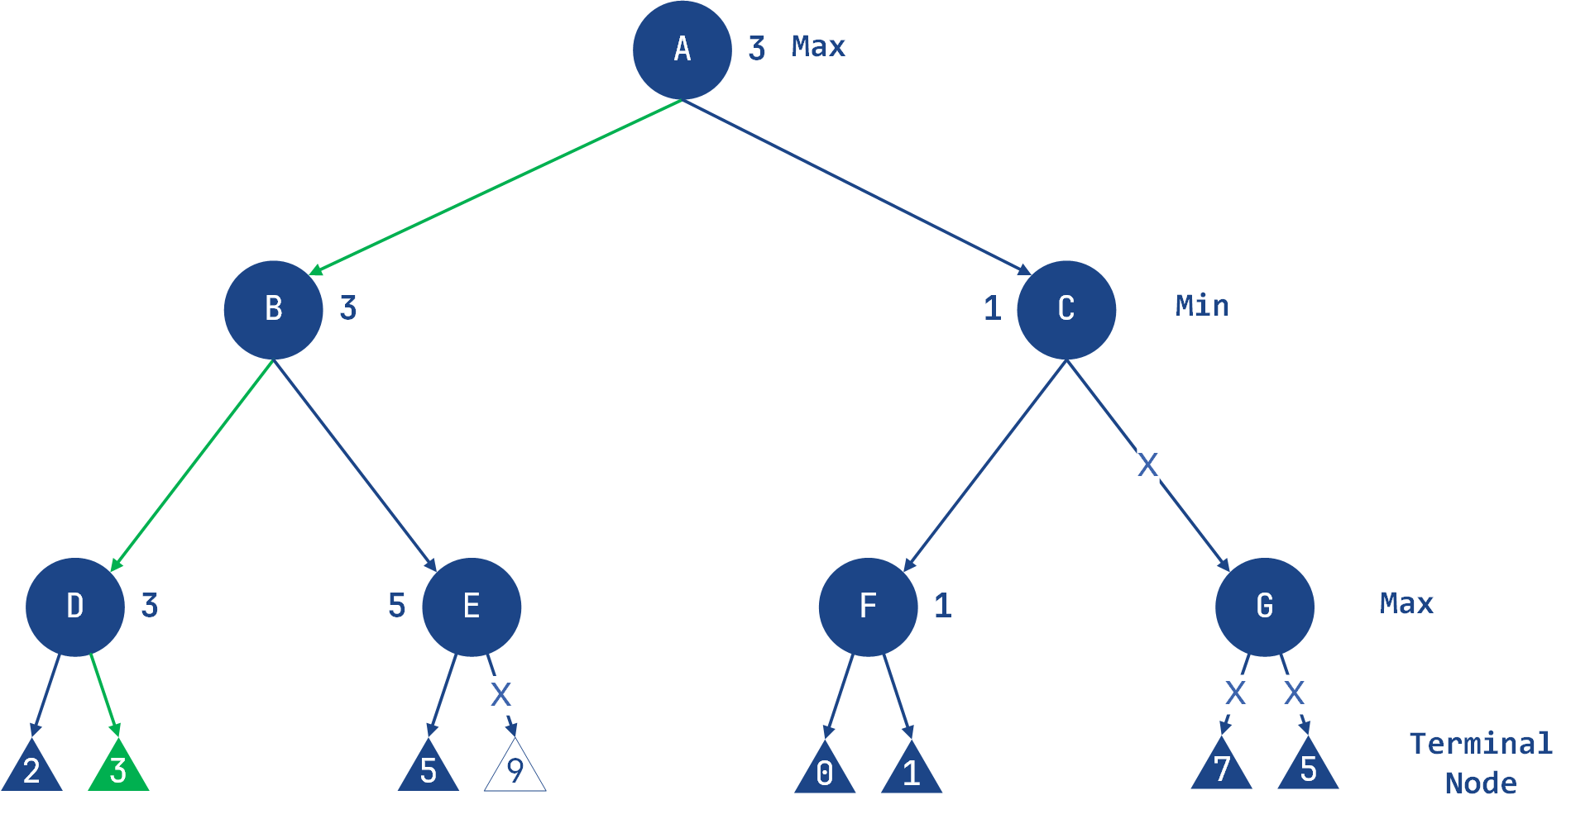

2.2.2.3 MiniMax with Alpha-Beta Pruning Algorithm - Example
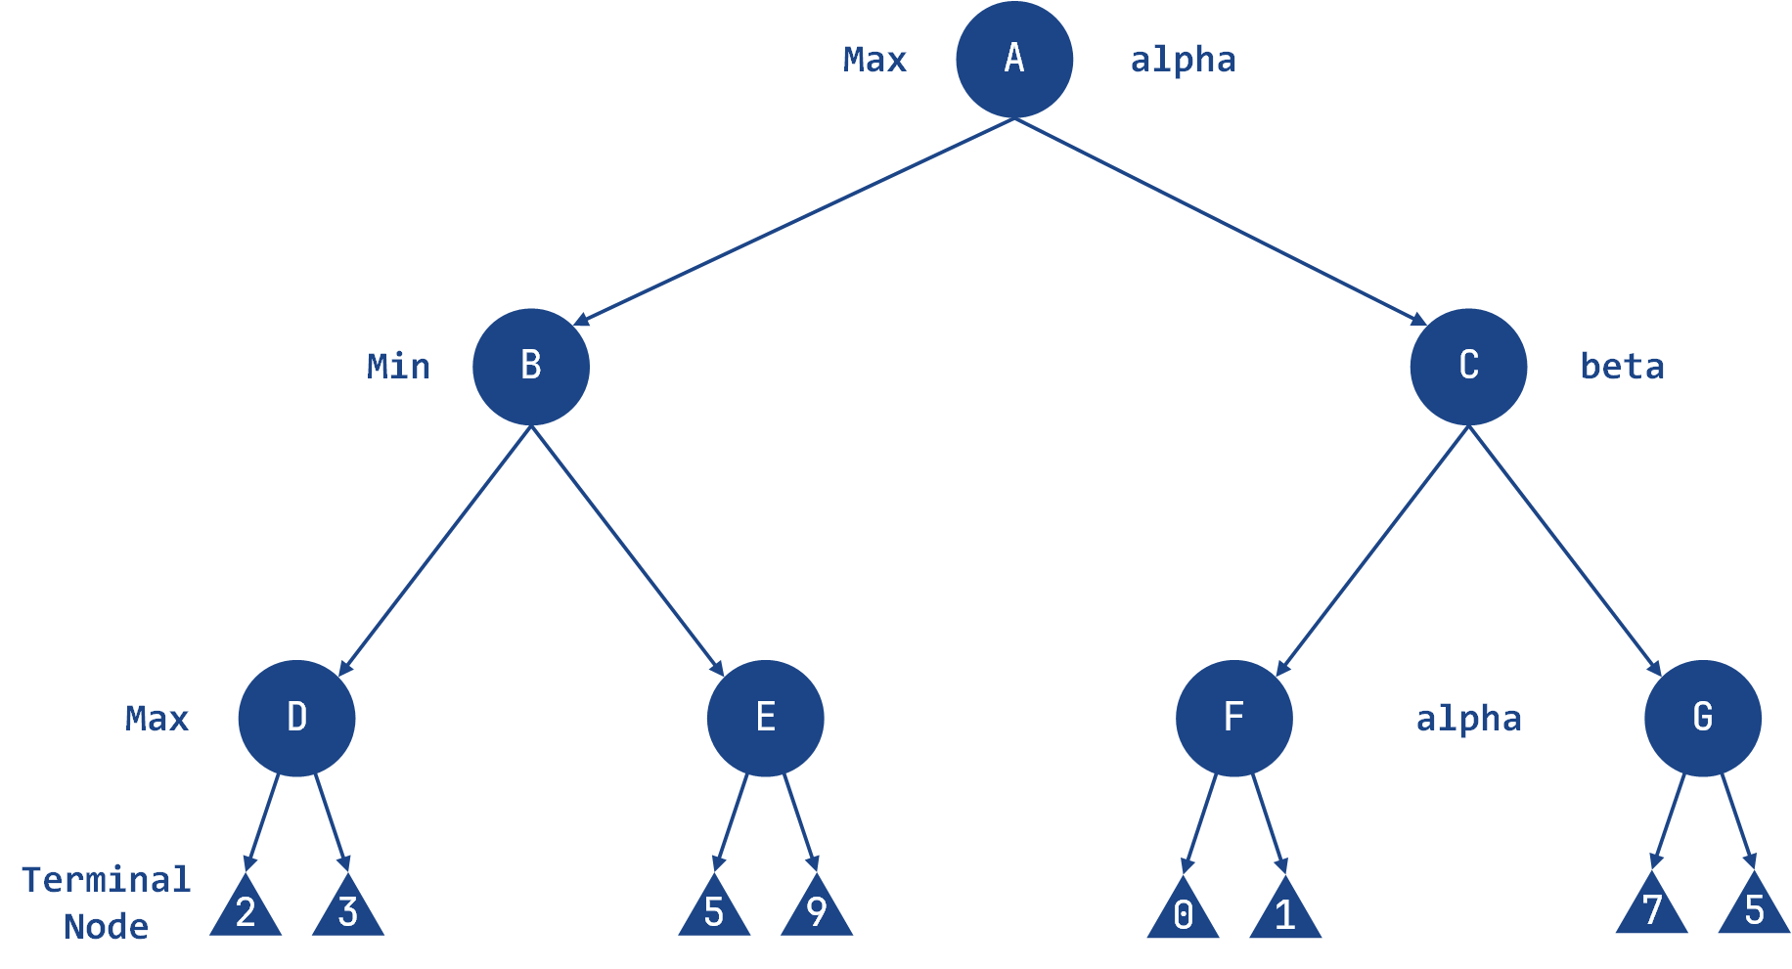

import math

class Node:
def __init__(self, value=None):
self.value = value
self.children = []
self.minmax_value = None

class MinimaxAgent:
def __init__(self, depth):
self.depth = depth

def formulate_goal(self, node):
return "Goal reached" if node.minmax_value is not None else "Searching"

def act(self, node, environment):
goal_status = self.formulate_goal(node)
if goal_status == "Goal reached":
return f"Minimax value for root node: {node.minmax_value}"
else:
return environment.alpha_beta_search(node, self.depth, -math.inf, math.inf, True)

class Environment:
def __init__(self, tree):
self.tree = tree
self.computed_nodes = []

def get_percept(self, node):
return node

def alpha_beta_search(self, node, depth, alpha, beta, maximizing_player=True):
self.computed_nodes.append(node.value)
if depth == 0 or not node.children:
return node.value

if maximizing_player:
value = -math.inf
for child in node.children:
value = max(value, self.alpha_beta_search(child, depth - 1, alpha, beta, False))
alpha = max(alpha, value)
if beta <= alpha:
print("Pruned node:", child.value)
break
node.minmax_value = value
return value
else:
value = math.inf
for child in node.children:
value = min(value, self.alpha_beta_search(child, depth - 1, alpha, beta, True))
beta = min(beta, value)
if beta <= alpha:
print("Pruned node:", child.value)
break
node.minmax_value = value
return value

def run_agent(agent, environment, start_node):
percept = environment.get_percept(start_node)
agent.act(percept, environment)

# constructing the tree
root = Node('A')
n1 = Node('B')
n2 = Node('C')
root.children = [n1, n2]

n3 = Node('D')
n4 = Node('E')
n5 = Node('F')
n6 = Node('G')
n1.children = [n3, n4]
n2.children = [n5, n6]

n7 = Node(2)
n8 = Node(3)
n9 = Node(5)
n10 = Node(9)
n3.children = [n7, n8]
n4.children = [n9, n10]

n11 = Node(0)
n12 = Node(1)
n13 = Node(7)
n14 = Node(5)
n5.children = [n11, n12]
n6.children = [n13, n14]

# define depth for Alpha-Beta pruning
depth = 3

agent = MinimaxAgent(depth)
environment = Environment(root)

run_agent(agent, environment, root)

print("Computed Nodes:", environment.computed_nodes)
print("Minimax values:")
print(f"A: {root.minmax_value}")
print(f"B: {n1.minmax_value}")
print(f"C: {n2.minmax_value}")
print(f"D: {n3.minmax_value}")
print(f"E: {n4.minmax_value}")
print(f"F: {n5.minmax_value}")
print(f"G: {n6.minmax_value}")
Output | Pruned node: 5  Pruned node: F  Nodes computed: ['A', 'B', 'D', 2, 3, 'E', 5, 'C', 'F', 0, 1]  Minimax values:  A: 3  B: 3  C: 1  D: 3  E: 5  F: 1  G: None

3. Lab Tasks
A security robot is deployed in a warehouse to prevent theft. The robot must decide its movement while anticipating the actions of a thief.
- The robot acts as the MAX player (aims to maximize safety).
- The thief acts as the MIN player (aims to minimize detection).
- The robot has two choices: Zone A or Zone B.
- After the robot moves, the thief chooses one of two hiding options.
Robot move | Option1 | Option2
Zone A | 3 | 5
Zone B | 2 | 9

- implement the above senario using agent enviroment which uses minimax to find the out come print all the states and moves .

Task 2
A self-driving car approaches an intersection and must decide its next action while considering the possible reactions of another aggressive driver.
- The self-driving car is the MAX player (maximizes safety and efficiency).
- The other driver is the MIN player (creates worst-case outcomes).
- The car has three options: Stop, Go, Turn.
- Each option leads to two possible outcomes as shown below.
Start
/ | \
Stop Go Turn
/ \ / \ / \
6 7 2 4 8 3
- Apply the Minimax algorithm to determine the best action for the self-driving car.
b) Apply Alpha-Beta Pruning to the given tree (show all steps clearly).
c) Identify which branches are pruned during the process.
d) How many nodes are not evaluated due to pruning?
Task 3
An AI agent is playing a turn-based strategy game and must choose among different actions while considering the opponent’s responses.
- The AI agent is the MAX player.
- The opponent is the MIN player.
- The decision tree has a depth of 3.
- Leaf node values represent utility scores.
Root
/ | \
Attack Defend Gather
/ \ / \ / \
A1 A2 D1 D2 G1 G2
/ \ / \ / \ / \ / \ / \
5 6 7 4 3 8 6 2 1 9 4 7
a) Construct the Minimax tree and compute the final decision of the AI agent.
b) Apply Alpha-Beta Pruning and clearly show the values of α (alpha) and β (beta) at each step.
c) Identify all pruned branches in the tree.
d) Compare the number of nodes evaluated in Minimax versus Alpha-Beta Pruning.
e) Briefly explain how Alpha-Beta Pruning improves efficiency in this scenario.

